**Creating and Managing EBS Volumes 🚀**

Let's walk through creating and managing your EBS volumes. It's easier than you might think

**Basic Volume Creation and Attachment 📦**

1. First, hop into your AWS Console and navigate to EC2 → Volumes

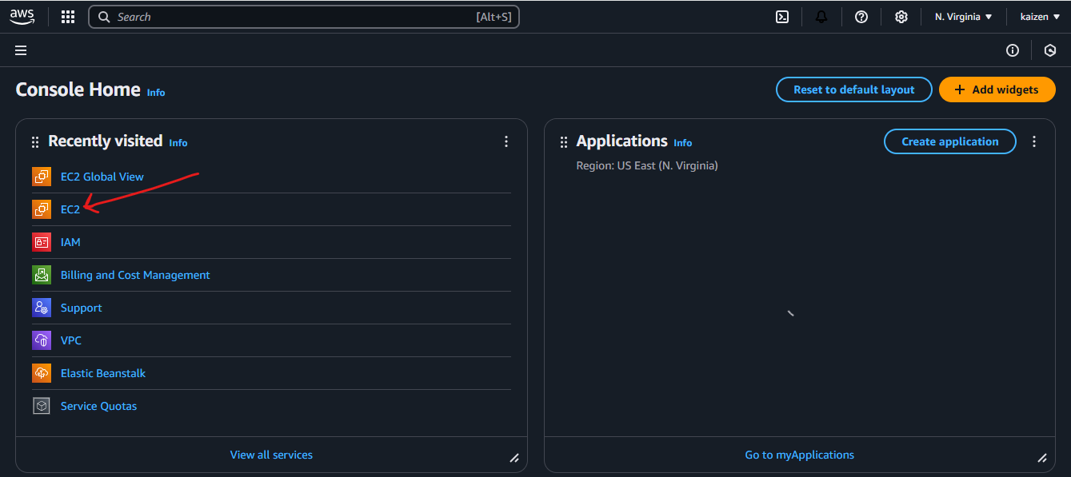

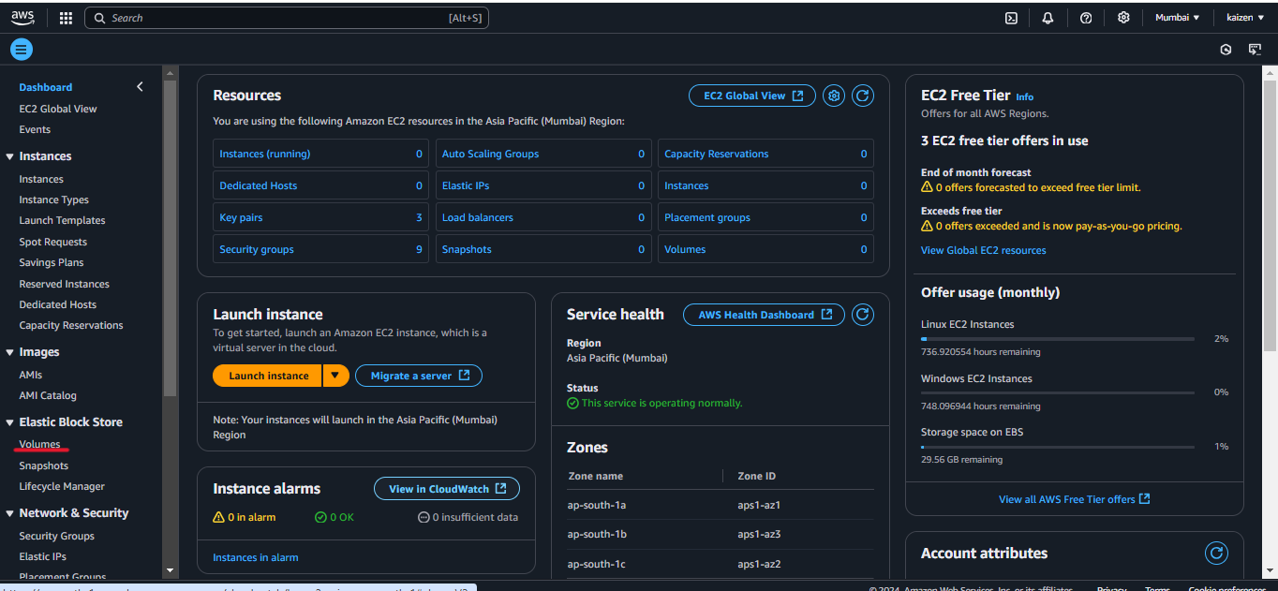

1. Click "Create Volume" and choose your settings:
   * Pick your size (let's say 8 GiB)
   * Select volume type (gp3 is a good default)
   * Choose your Availability Zone (make sure it matches your EC2 instance!)
   * Add any tags if you want to stay organized

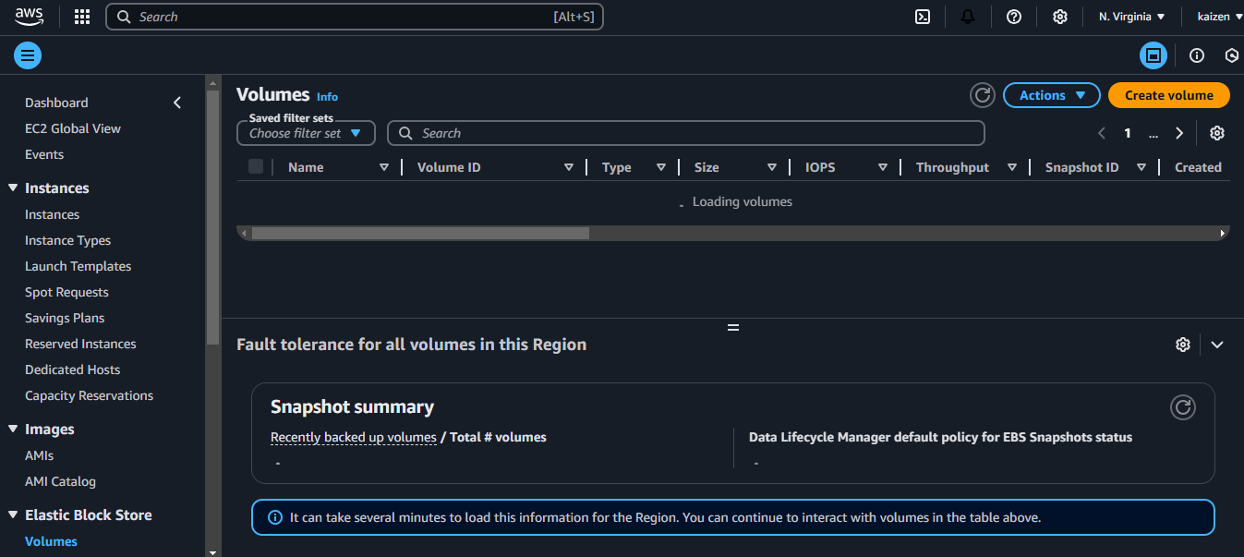

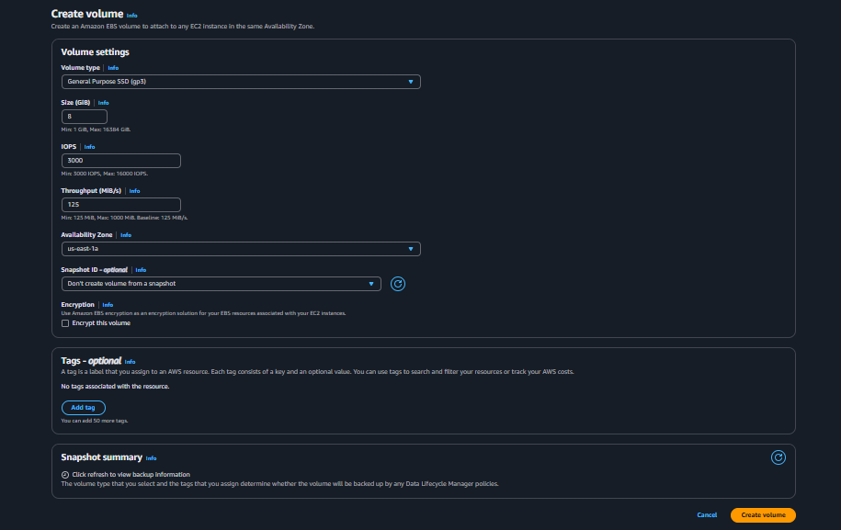

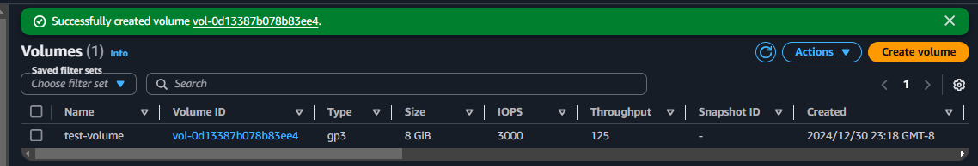

1. Once created, right-click the volume and select "Attach Volume"

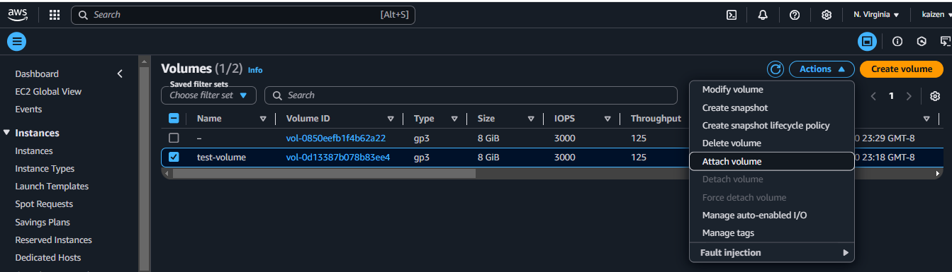

1. Pick your EC2 instance from the dropdown and note the device name (like /dev/xvdf)

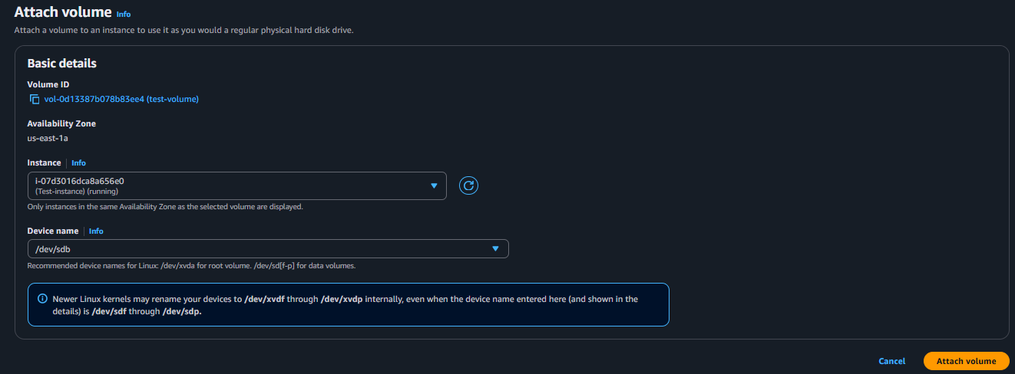

**Modifying Your Volume 🔧**

1. Need more space? Right-click your volume

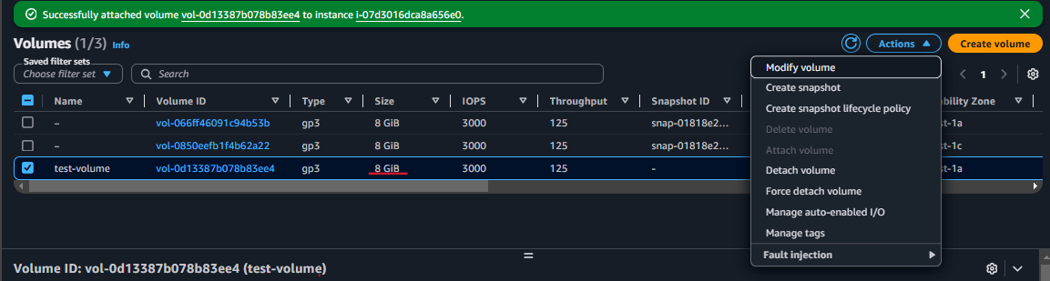

1. Select "Modify Volume"
2. Change the size or type (like going from 8 GiB to 16 GiB)
3. Click "Modify" and wait for the status to change to "optimizing"

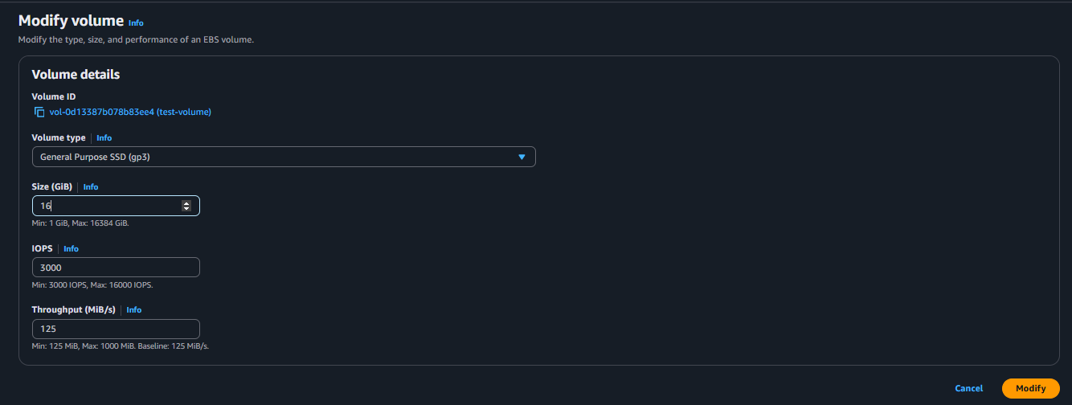

**Creating and Moving Data Between Instances Using Snapshots 📸**

Let's create some data and make a snapshot

**Setting Up Your Data**

1. Connect to your EC2 instance:
   * Go to EC2 Dashboard → Instances
   * Select your instance
   * Click "Connect"
   * Choose "EC2 Instance Connect"
   * Click "Connect" to open the browser-based terminal

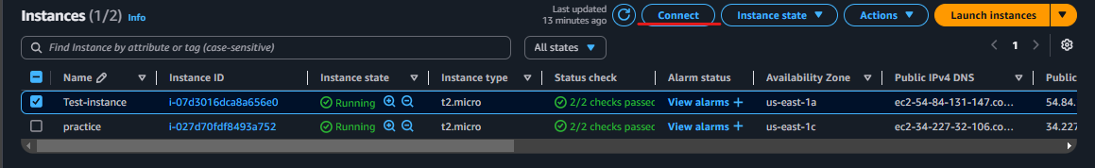

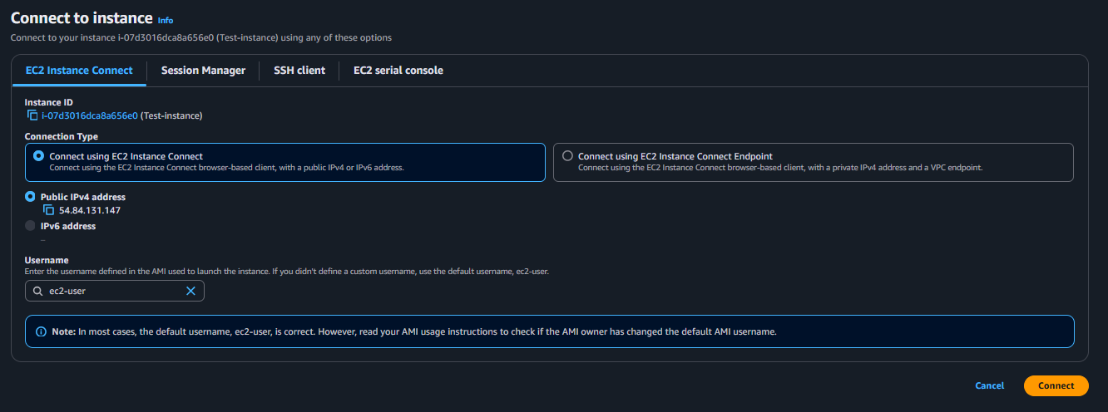

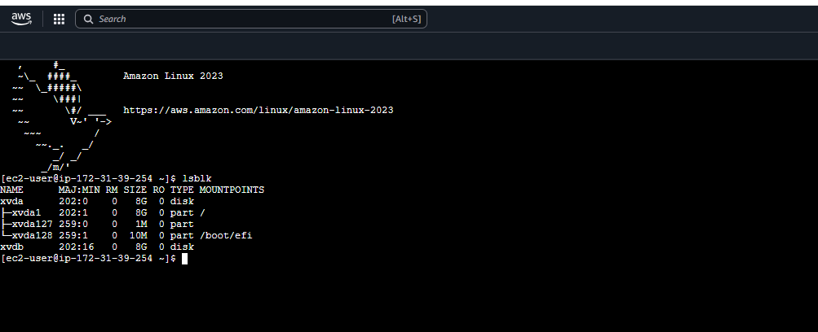

Create a test folder and file

cd /data

sudo mkdir test-folder

echo "Hello Thereee"> test-file

**Creating and Using Snapshots**

1. Back in AWS Console, select your volume
2. Click "Create snapshot"

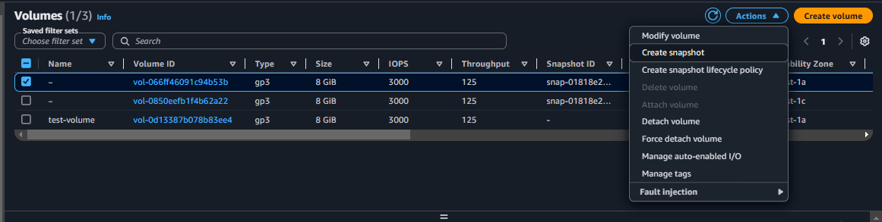

1. Add a description like "My test data backup"

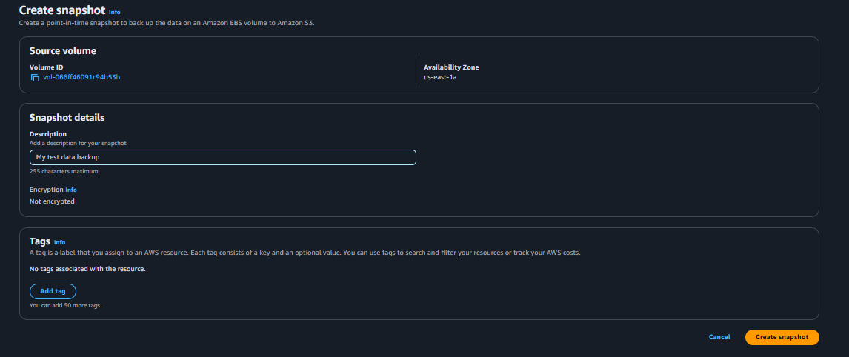

1. Wait for the snapshot to complete (Status: Completed)
2. Create a new volume from the snapshot:
   * Select your snapshot
   * Click "Create volume from snapshot"
   * Choose a different AZ this time!
   * Keep other settings the same

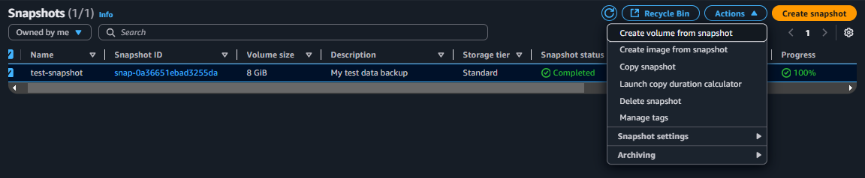

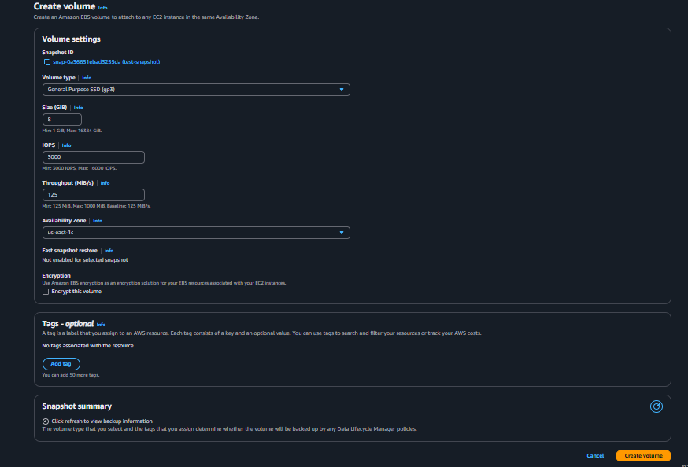

6. Connect to the new instance using EC2 Instance Connect and mount:

1. Attach this new volume to another EC2 instance in the new AZ

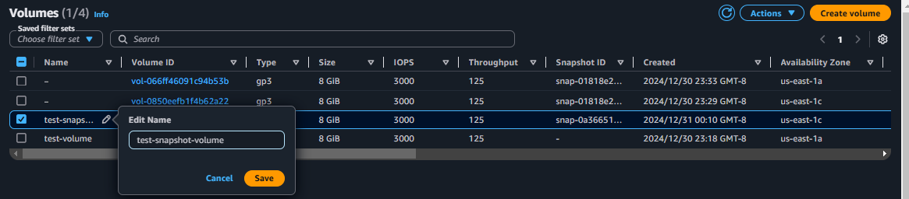

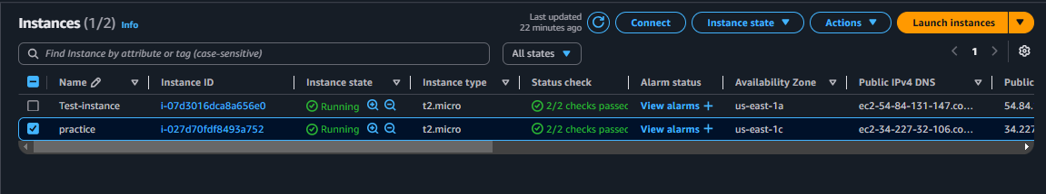

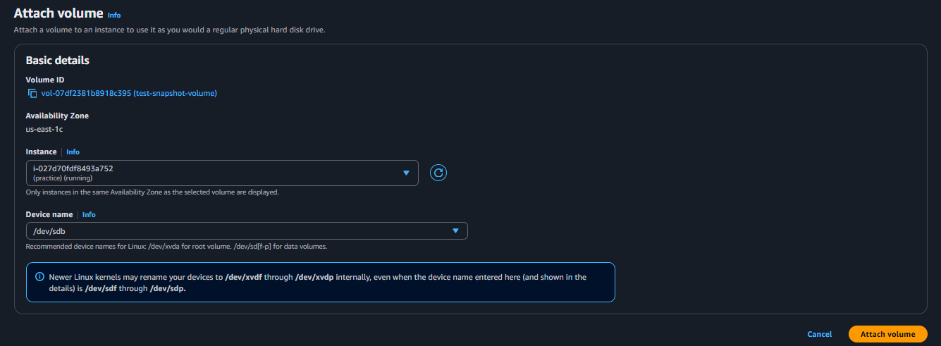

1. Verify your data:

Remember the test-folder and test-file we created earlier now it’s time to retrieve those puppies back in our new instance with the help of following cmds.

lsblk

sudo file –s /dev/<the first disk partition of your instances attached volume>

sudo mkdir /mnt/mybackup/

sudo mount –o nouuid /dev/<the first disk partition of your instances attached volume> /mnt/mybackup/

df –h

cd /mnt/mybackup/

ls

cd home/ec2-user/

cd test-folder/

ls

cat test-file

what’s happening here is the device name (like /dev/xvdb1) is crucial because it's how the Linux/Unix operating system will identify and reference your EBS volume.

1. When done, unmount:

sudo umount /mnt/mybackup

or

sudo umount –l /mnt/mybackup

df -h

**Copying Snapshots Across Regions 🌎**

1. Select your snapshot in the source region
2. Click "Copy snapshot"

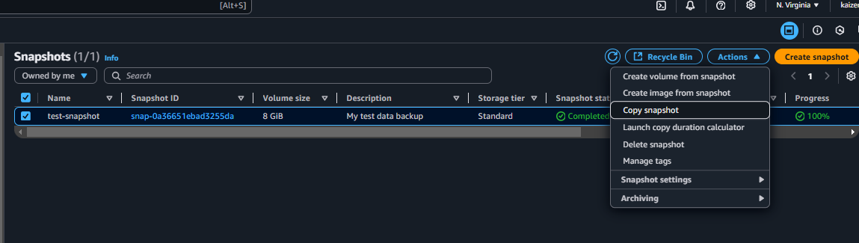

1. Choose your destination region (like us-west-2 if you're in us-east-1)
2. Add encryption if needed
3. Wait for the copy to complete

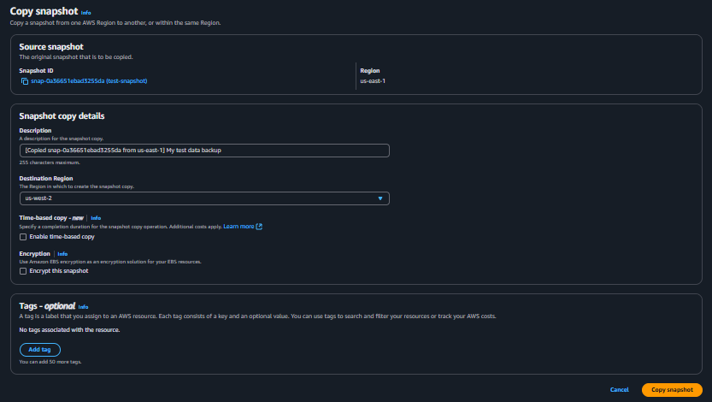

1. Switch to the destination region and from here on all the steps are similar to the previous process.
2. Create a volume from the copied snapshot
3. Attach to an EC2 instance in the new region
4. Mount and access your data as we did earlier.

**EBS Lifecycle Manager: Your Automated Backup Buddy**

Now you would’nt want to create, delete, copy , automate regular backups (snapshots) and AMIs manually of your volumes, you could always leave this task to lifecycle Manager it helps maintain compliance requirements, saves money by automatically deleting old snapshots and reduces human error in backup processes

**Setting Up Lifecycle Manager**

1. Go to EC2 → Lifecycle Manager

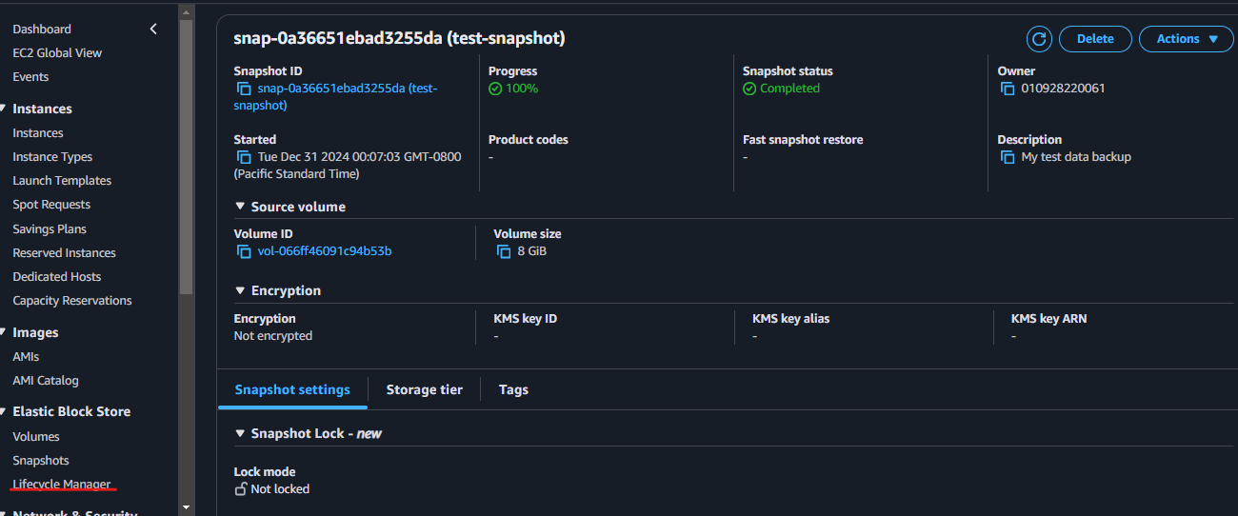

1. Create a lifecycle policy:

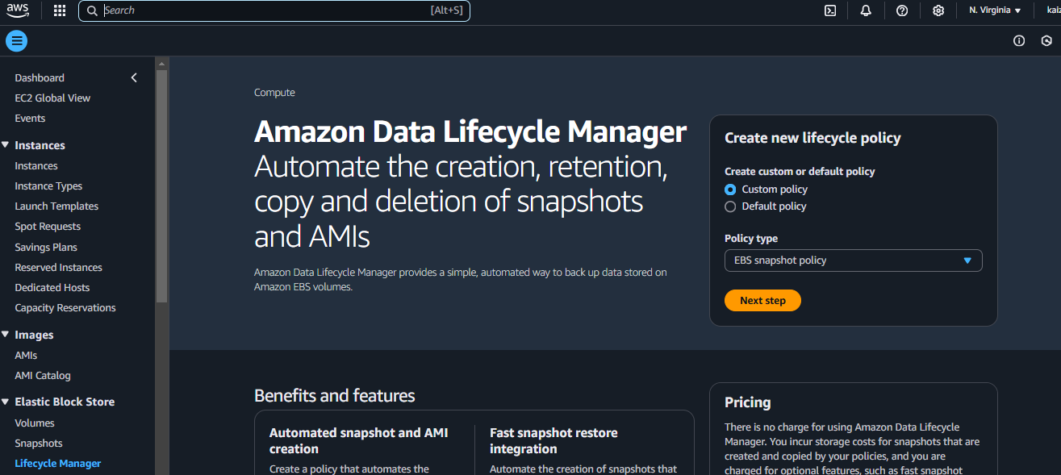

* + Choose "EBS snapshot policy"
  + Select your target resources (by tags or volume ID)
  + Set your schedule (like every 24 hours)
  + Choose retention (like keep last 7 snapshots)
  + Enable cross-region copy if needed

**That’s it now you know your EBS’s ☺**